Small Business In-Branch Workshop Day 1
Date | 06/05/23 |  | Location | Edmonton
Time (From / To) | 13:00 to 15:00 |  | Facilitators | Angela Ahn & Dan Riberdy
Attendees
CWB |  | Accutive
- Candyse Watkinson  - Ian Hicks  - Ali Anwar  - Amelie Teodosio  - Kelvin Fernando  - Dele Fatubarin  - Fusi Olateru  - Saba Chokkalingam  - Christina Robertson  - Chris Monita |  | - Angela Ahn  - Dan Riberdy (meeting organizer)  - Sampada Deshpande  - Blake Hunter  - Lucy Liu

Objectives:

- Gather and finalize requirements for Small Business In-Branch

Discussion Notes

In Workshop Day 1 we discussed and reviewed the following:

- Need to amend the landing page to accommodate Business vs. Personal applications – per sample mock-up depiction below:

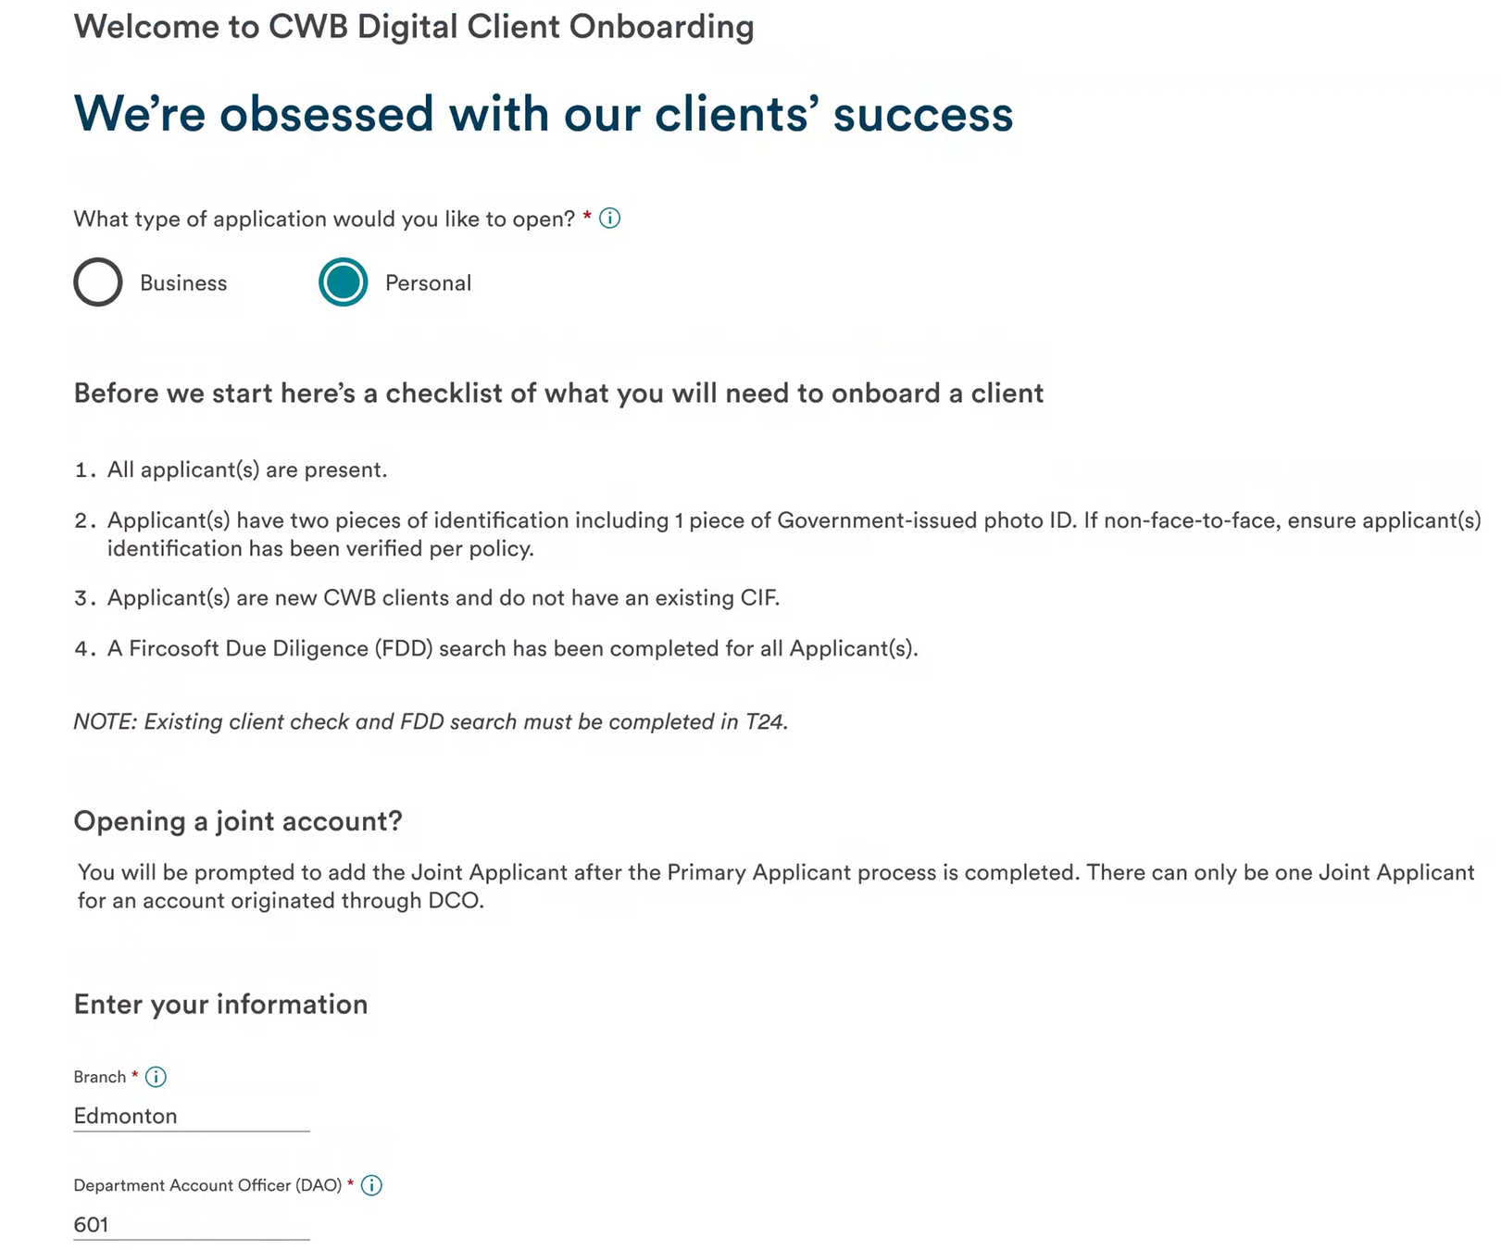

The checklist will need to change depending on Business vs. Personal applications – action item CWB.

Depending on which option is selected – Business vs. Personal – the next button will route the application to the appropriate LOB form.

- Need to develop a new page to search for business registration – per sample mock-up depiction below:

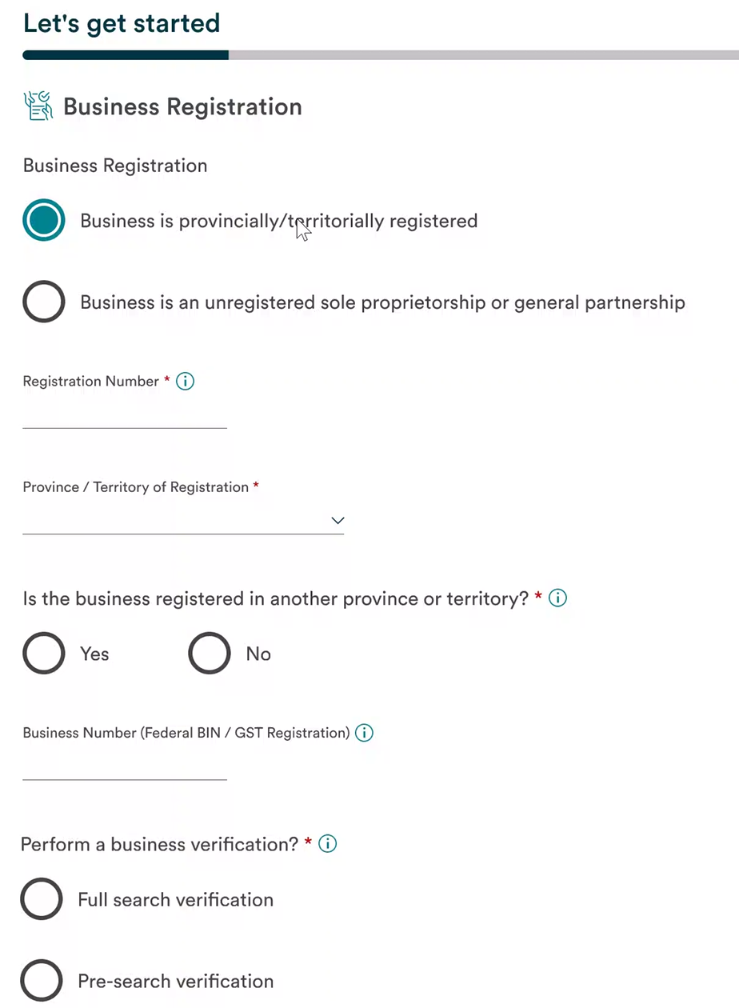

3 search scenarios to be considered:
- Full business verification (active business get COVR)
- vs. search without COVR
- vs. skip search

Note: COVR = Customer On-Boarding Verification Report

Need to display search result in UI?
– Popup modal vs. current page – detailed info vs. summarized

Need modal with moving shards and messaging while COVR is getting pulled – language TBD.

If COVR doesn’t come back quickly, need to allow users to enter data manually, and while doing so, if report comes-in, need to let users know.

Once the COVR report comes back, if the user has already started entering info manually, ignore the report and continue with manual process. i.e. the report data is NOT to override the manual info already entered.

- Assuming COVR comes back quickly – do we need to auto-fill the below page using the COVR report returned info?

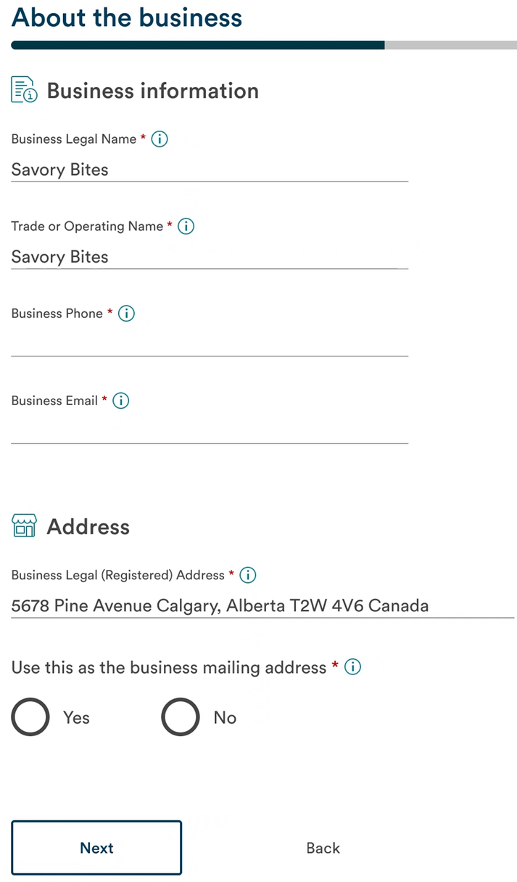

- We may need to allow a longer list of business types for in-branch (as compared to self-serve).

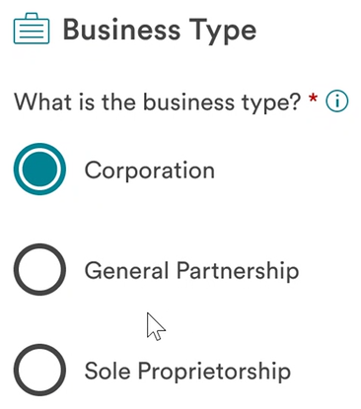

Action item: new list of In-Branch business types to be provided by CWB

If the number of In-Branch business types is long enough, do we want to display them via a dropdown instead of radio buttons?

- Need the ability to add multiple ownership documents – per sample mock-up depiction below:

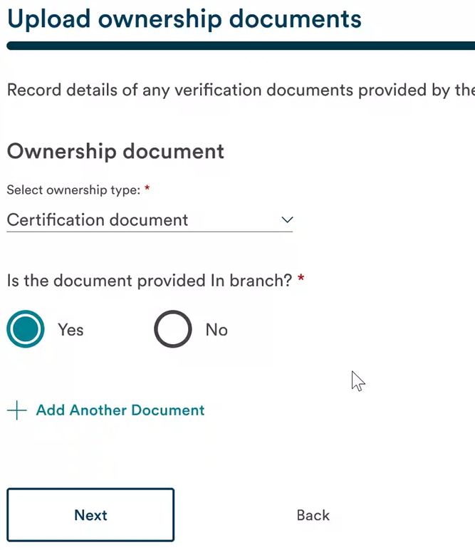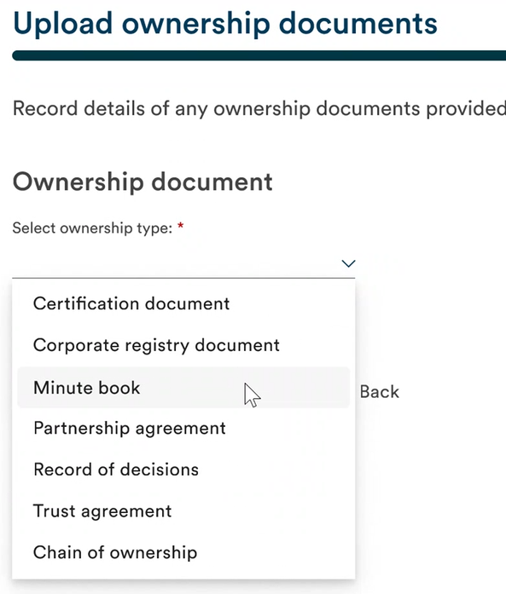

Need to determine whether the documents will be provided in-branch (physical documents) or if the answer is no, then an [Upload] button should be provided. Language around this question to be refined.

- We also need to have a legal document – per sample mock-up depiction below:

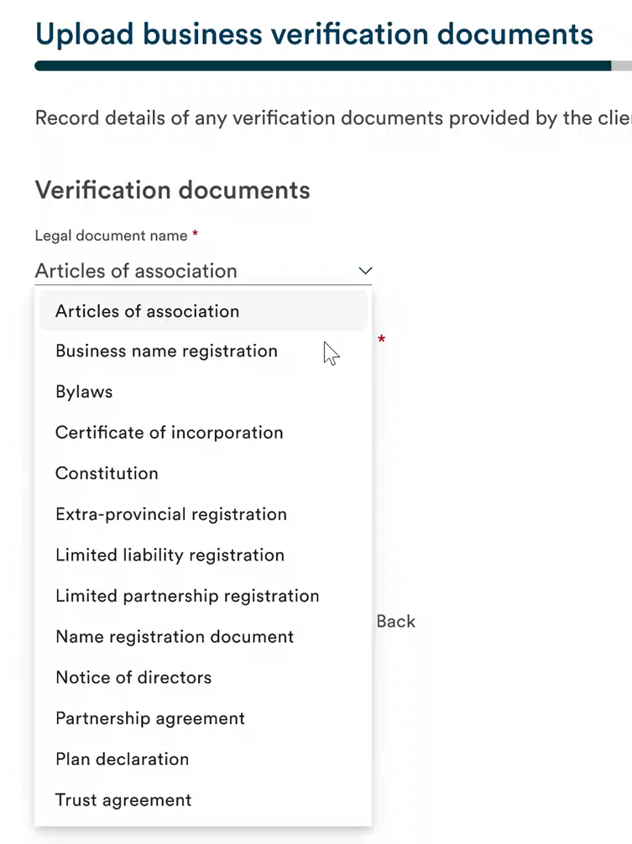

Would it be possible to have a dynamic grid of required documents based on business types?

- Product selector is identical to Small Business Self-Serve.

- The business associates page is the same as Self-Serve with the exception that customers could already have a CIF – in which case we would need to search for it and pre-fill their info – per sample mock-up depiction below:

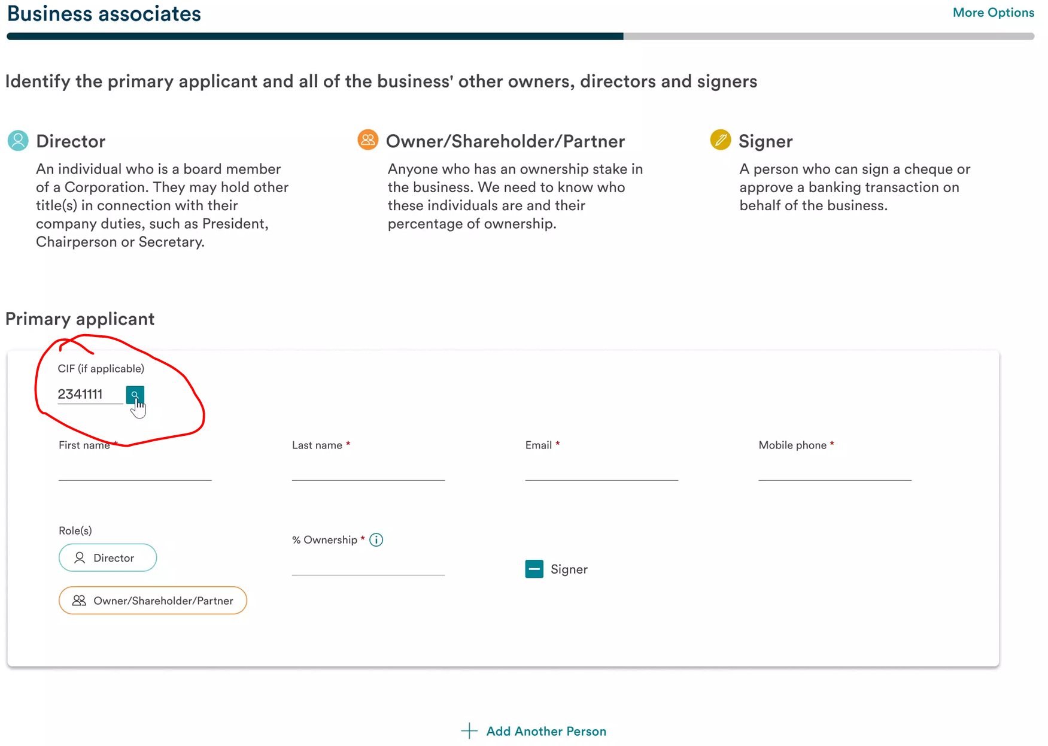
- Additional applicants – need to have a new checkbox for Send invitation when additional applicants are not in-branch with the primary applicant – per sample mock-up depiction below:

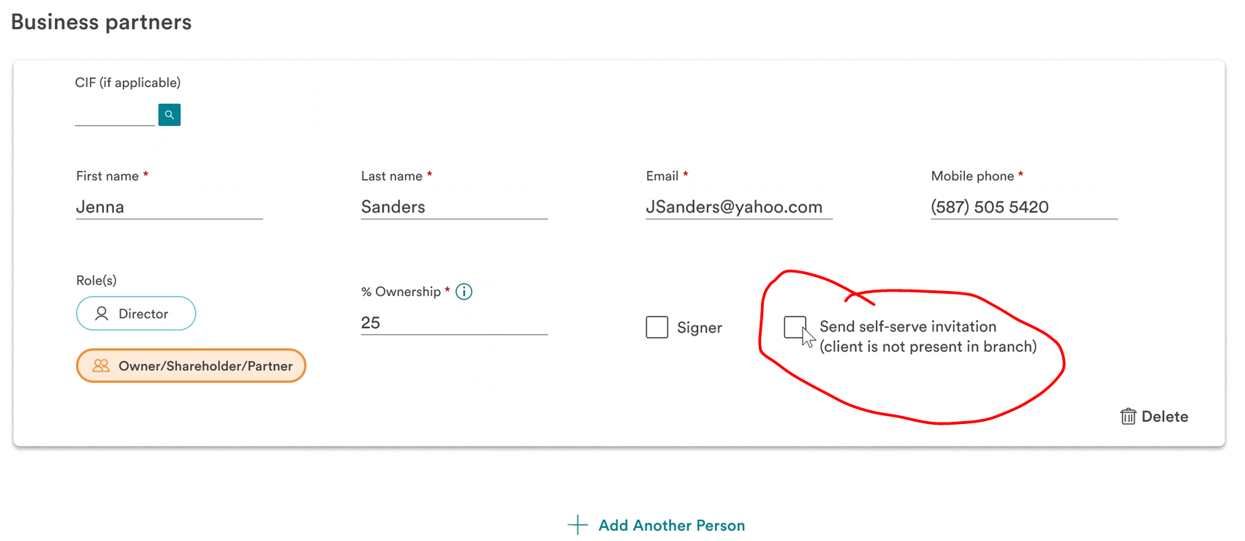

Need to determine whether this checkbox can be within the card or outside.

- The following pages should be rendered for applicants without CIFs – loop back through for all additional applicants without CIFs:

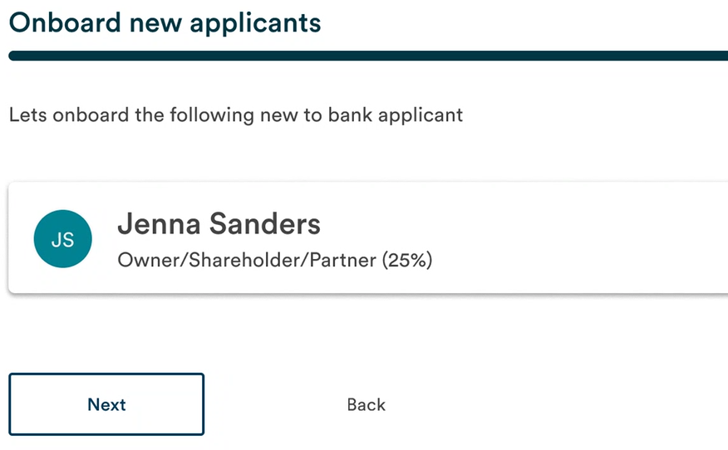

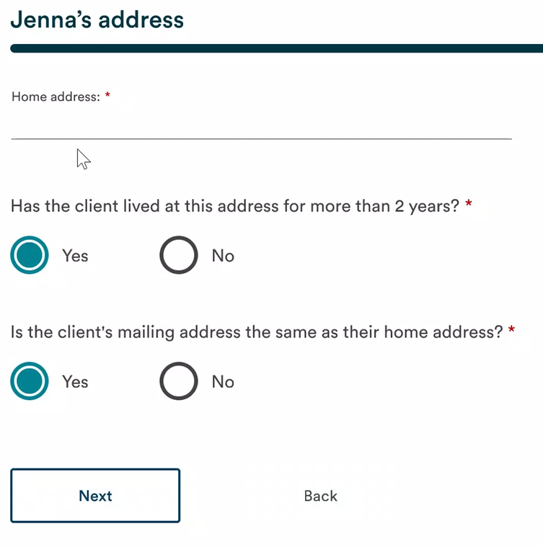

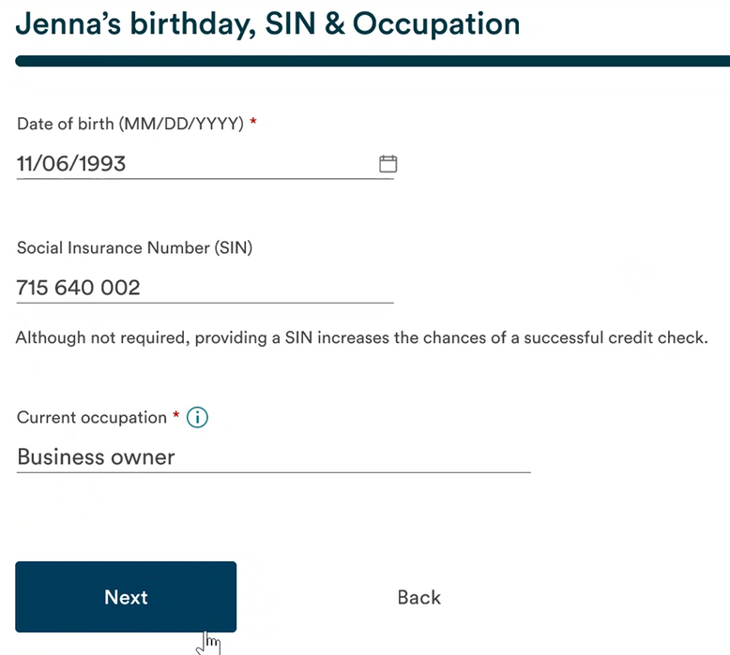

- Client ID page – Re-use the Client ID page currently in Personal IN Branch – no changes require

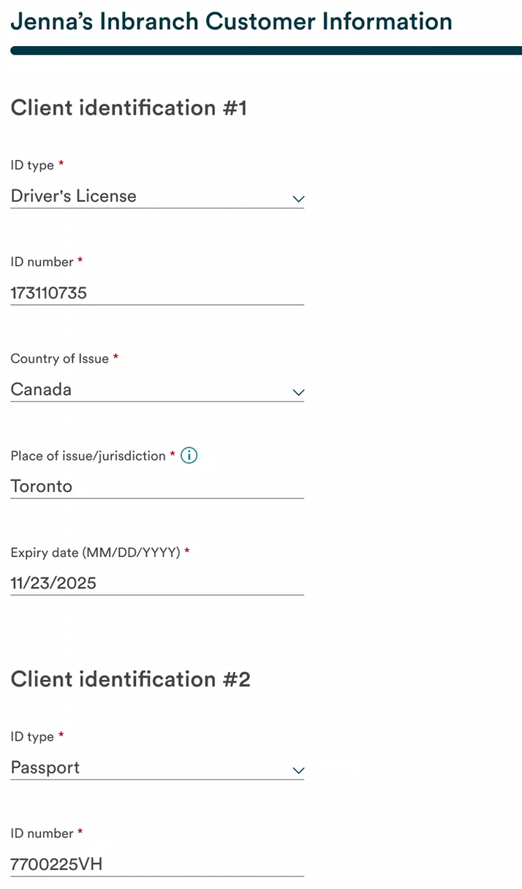

- Changes will be required on this page – Next Step Options.

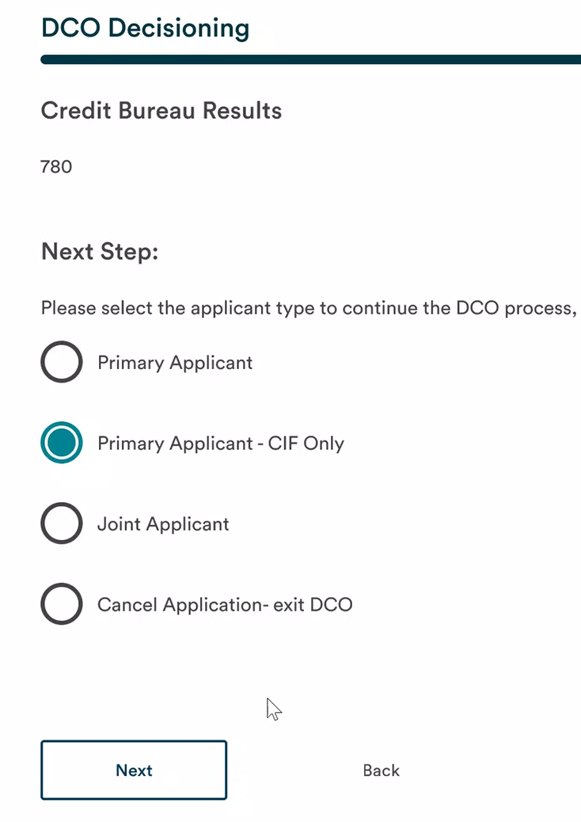

Need to send resume emails to the branch’s general email address Inbox.

- Debit cards & online banking selections for applicants – per sample mock-up depiction below:

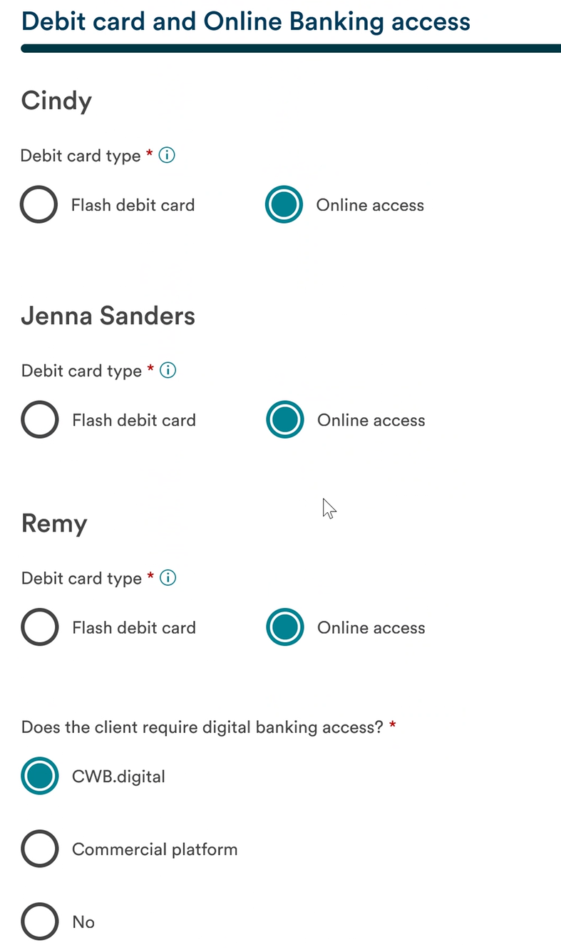

- Summary page – per sample mock-up depiction below:

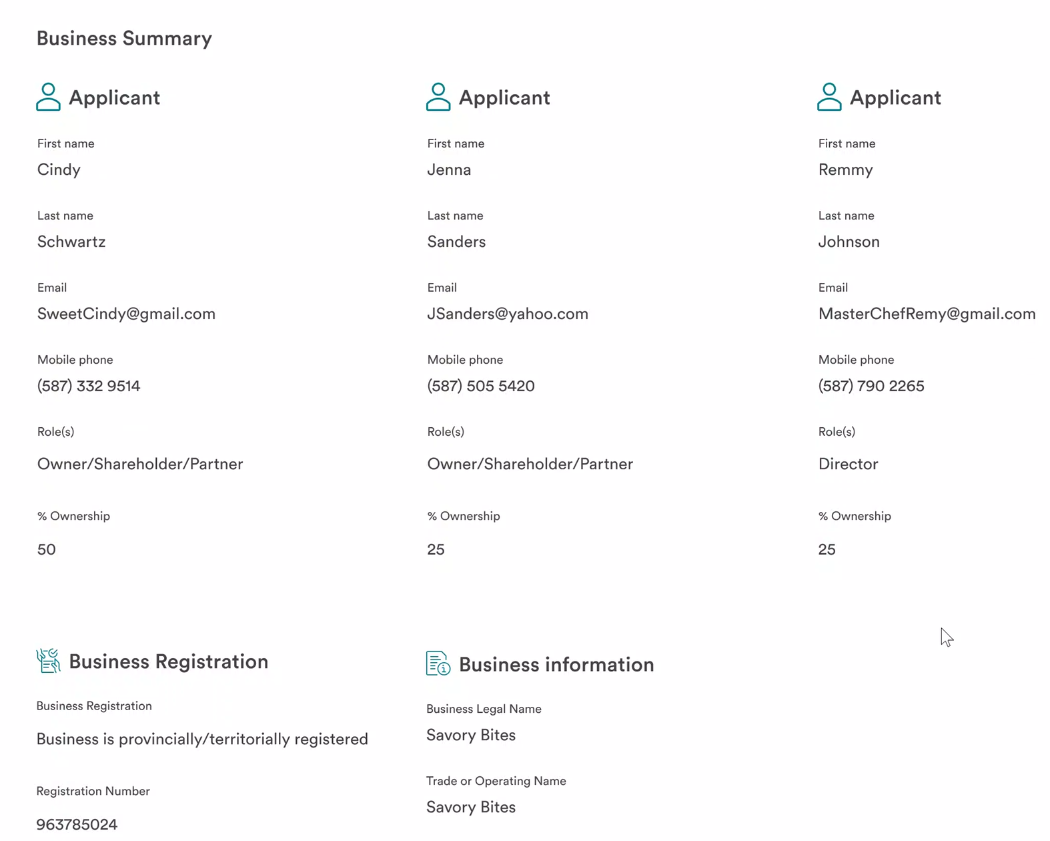

Action Items

# | Action Items | Responsible
1 | Need to research if the COVR report data can be used to pre-fill applicant info  Could COVR return info faster? | Sampada
2 | For (New) Business Parties (Owners, Directors, Signers & other roles) page do we need to modify the template, in order to add:  - CIF field in the card to search for data pre-fill for applicant  - Send self-serve Invitation checkbox  These 2 fields might need to be added outside card to avoid a template change. | Lucy
3 | Look into leveraging the Get Customer service to execute search when CIF is entered to pre-fill, First name, Last Name, Email and Mobile | Sampada
4 | Need to finalize the Landing page checklist content depending on whether it is a Business vs. Personal application | CWB
5 | Finalize additional business entity types (i.e., Non-Profit) need.  Impact: Update the mapping to T24. (No other changes will be required) | CWB
6 | Documents Upload - CWB have workout how it will look like as T24 needs 2 type documents to create the Biz CIF and other documents are bonus that are not needed by T24 but required by staff for decision purpose /audit purpose as part of SFPT delivery. | CWB
7 | Would it be possible to have a grid of documents to be selected – document selection conditionally displayed based on business type | Lucy

